Social Studies 10-1: Unit 1 Module Globalization and Identity
To what extent should globalization shape identity?
In this Unit we will be exploring the meaning of globalization and how it affects you. Understanding the role globalization plays in your life today, will help you to form opinions about the extent to which you feel we should embrace it.
Globalization is a key concept that permeates our lives. Look at your life and where the things you are wearing or using come from. You will notice that very few things around you were created in Canada. Most of the things you wear, eat, and use come from a variety of different places where other people live, work, love, and dream just as you do.
To better understand both your world and how it interconnects with the rest of the globe we are going to explore the concept of globalization, what it means, how it has evolved, and how it impacts our lives and world.
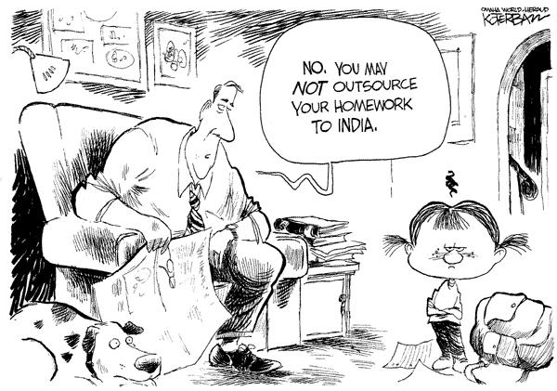
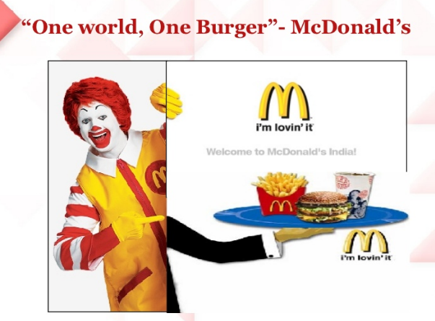

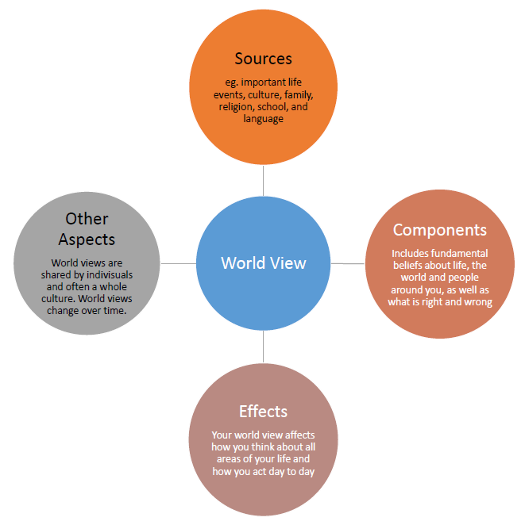

Part 1/Chapter 1: Understandings of Globalization
READ CHAPTER 1 PDF OR THE TEXTBOOK YOU SIGNED OUT FROM YOUR SCHOOL
In this part of the course you will be asked to ponder, research and analyze information so you can answer the following questions:
- What is globalization? (1.1)
- How does globalization influence my life? (1.2)
- How does globalization affect economic, social and political aspects of people's lives? (1.3)
- How does globalization affect people's identities? (1.4)
key terms:
- context
- role model
- Collective
10-1 Related Issue 1 Vocabulary

Use a dictionary, your textbook or the internet to understand and record the meanings of each of the following terms.

1. Globalization:

2. Tradition:

3. Cultural assimilation:

4. Norm:

5. Stewardship:

6. Sustainable:

7. Revitalization:

8. Culture:

9. Homogenization, Cultural Homogenization (see the chart further below!):

10. Accommodation:

11. Global monoculture:

12. Cultural revitalization

13. Acculturation

14. Marginalization

15. Convergence

16. Monoculture
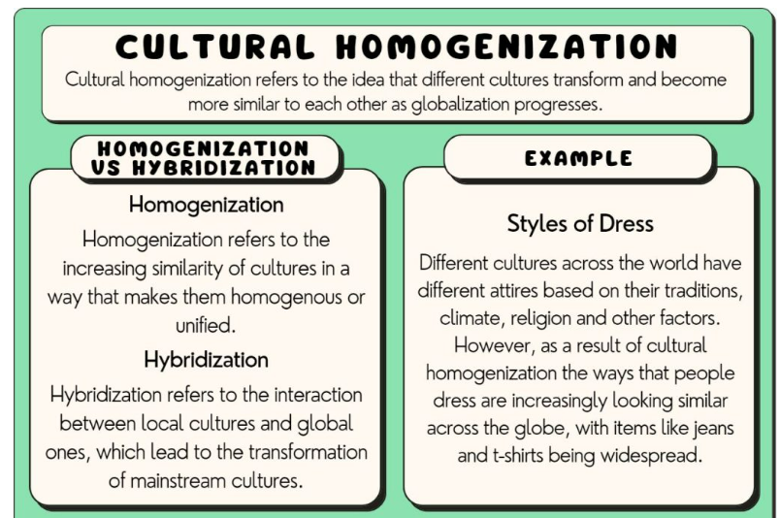
Cultural homogenization refers to the idea that different cultures transform and become more similar to each other as globalization progresses.
This process can take place both at a local level, such as a single city or country, or at a global level, among different cultures across the globe. Examples of cultural homogenization include the development of a global culture, McDonaldization of industry, and global Americanization. As a result of cultural homogenization, local and indigenous cultures lose their authenticity in favor of the dominant Western, particularly American, norms and values (Pritchard, 2009), and global stratification is exacerbated. This concept is closely related to other sociological concepts such as globalization, cultural imperialism, and assimilation.
HYBRIDIZATION: Cultural hybridization refers to the interaction between local cultures and global ones, which lead to the transformation of mainstream cultures (see also: glocalization and cultural blending). Hybridization is closely related to interactions between different cultures, and multiculturalism. An example of cultural homogenization would be the widespread consumption of American fast food in the Middle East, while an example of hybridization would be the popularity of Middle Eastern Doner Kebabs in Europe, as a result of migration from this region.
Another way to think about hybridization is that it is the combining of the elements of two or more different cultures to create something new. For example, Sesame Street combines elements of American culture, and combines it with the culture of another country where it is produced. It is produced in many countries around the world. Read: Sesame Street
What are your thoughts on the messaging by Sesame Street?

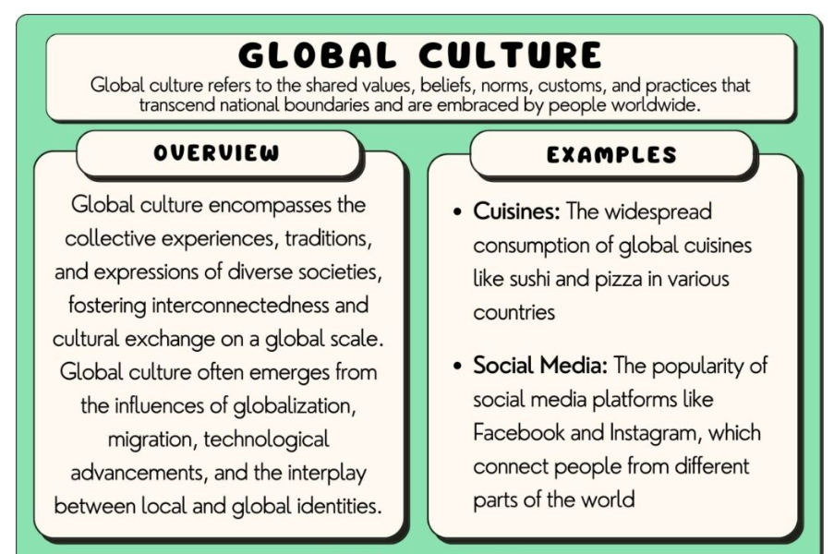
The era of globalization has created a global culture where people around the world share experiences, ideas, norms, and symbols that unite them.
Music, movies, clothes, and phones in the era of globalization are designed to appeal to a global market. This has helped to create global interconnectedness. Examples of global culture include Hollywood films, fast food restaurants, and pop music. These examples can be used in human geography studies. (Click the blue links as you go!)

Examples Of Global Culture

1. Hollywood Film
Hollywood’s film industry produces movies that are watched around the world. These films consequently spread US culture and values far and wide.
Movies like the Marvel and DC film franchises make US culture and values known around the world. They idealize and promote an American way of life and are persuasive in getting youths around the world to embrace Western culture (Song, 2018).
2. English: The Global Language Of Business
Each country has its own national language or mother tongue, but when the need for international communication arises, a common language has to be used.
Given the dominance of the United States in the 20th Century, English has become the business world’s lingua franca. Multinational companies like Samsung, Microsoft in Beijing, Renault, to name a few use English as the common corporate language. Companies around the world have pivoted to English as their form of communication so they can break into the large US domestic market, attract American talent, and communicate seamlessly with US-based investors.

3. Fast Food Restaurants
When it comes to eateries, Fast food restaurants are very easy to spot in almost any developed and developing country.
Many people around the world are familiar with names like McDonald’s and KFC. These fast-food restaurants have become a part of a modern lifestyle through their integration into societies around the world and it shows the scope of food globalization. Even in societies that don’t have McDonald’s, the fast-food style eatery that was pioneered by the Mcdonald’s franchise has spread far and wide. This even has a name: McDonaldization. Mcdonald’s started as a single restaurant in the United States of America but over the years it has become one of the biggest food chains in the world with over 39,000 locations in over 100 countries.
DO:
Google the McDonalds menu in France, Italy or Germany. What are some interesting items they sell different to the menu in Canada:

4. The Five Great Religions
The five religions of the world were some of the first examples of global culture – they all spread into nearly every multicultural country, influencing each country’s culture and development.
These religions are Judaism, Christianity, Islam, Hinduism, and Buddhism. These religions share many similarities and beliefs. All believe that God created the universe and all that exists in it. Another similarity is that they all emphasize the importance of ethical behaviors and a sense of community all over the world.
These religions share common practices too such as praying, fasting, and giving to charity. During Ramadhan, Muslims all over the world get to celebrate. This is also the same during the Christmas season, where Christians all over the world get to celebrate. These holidays are similar because they foster the spirit of giving and sharing with the less fortunate in society.

5. The United Nations
The United Nations is a global body that all recognized nations of the world contribute to and, to one extent or another, most countries obey the UN charter and rules.
The UN was founded in 1945 as an International Organization. It is made up of 193 Member states and they are guided by the purpose and principles which are contained in the founding charter. This International Organization has evolved over the years with its work to keep pace with a rapidly changing world. The UN represents global culture inasmuch as all the world’s nations gather together to discuss common problems so as to try to seek solutions that can benefit all humanity. It is also through the UN that we have the Sustainable Development Goals which unite us all. These Sustainable goals are a call for action by all countries poor, rich and middle income to promote prosperity while protecting the planet.

6. International Fashion Trends
Globalization has opened up a clothing market with a massive demand for fashionable and trendy clothes. The trends from Paris rapidly make their way to New York, London, and Tokyo.
Fashion images in magazines, music videos, the Internet, and television have helped create a global style across borders and cultures.
Across the world, from Europe to Africa, you will find people wearing jeans, designer sports shoes, T-shirts, and dresses. Asian, African and Western fashion systems borrow style and textile elements from each other. Each consumer is catered for, different ages, gender, ethnicity, profession, and subculture in high tech bazaars. World-known celebrities also play a role in spreading a particular fashion through Instagram. Most emerging fashion trends emerge here where millennials and Generation Z are very much active. An example of a relatable fashion is the Yeezy shoes which have become a fashionable trend among youths around the world.

7. Pop Music
Pop music charts have become more globally oriented since the 1960s. In addition to that, the arrival of music televisions such as MTV in 1981 helped music from different artists to be broadcasted across the globe.
Today, pop music is marketed through radios of different frequencies, and more TV shows have emerged internationally

8. Consumer Culture
Global consumer culture has emerged during the previous few decades.
This culture has been promoted through the rise of standardized online shopping platforms like Amazon, as well as the spread of capitalism in the 20th Century.
Consumers no longer shop only locally and in-person. They also routinely buy things from other countries, both online and offline. Many companies offer their goods all over the world. As a result, businesses are adjusting their marketing tactics to appeal to growing global customer segments who are interested in foreign and/or global market goods.
What is Globalization? Click on the blue video link below!
Crash Course World History: Globalization
Once you’ve watched the video, answer the questions below:
Crash Course: Globalization I Questions

- What item does John Green argue tells the story of globalization?

- List two reasons that make globalization today different from trade in the past?

- What makes American cotton so much cheaper?

- Why is the spinning and weaving done elsewhere?

- Where is the screen printing usually done?

- What aspects of this trade are the most expensive?

- What organization (initials IMF) provides loans to poor countries but requires they open up to free trade type policies?

- Where was your computer probably manufactured?

- Who do people in Brazil, China, and similar countries primarily make computers for? How is this different from American cars within the US in the Industrial Revolution?

- How many people have emerged from poverty in the last 30 years?

- What are some negative side effects of globalization?

- What three reasons have led to migration becoming more common?

- People moving leads to _____ blending.

- How many hours would a Mongols shirt cost you? How does this compare to the cost of a few hundred years ago?

- What reason does John Green offer for studying history?

- John Green says it is both easy - and dangerous - to feel a certain way as a result of our accomplishments; how should we be careful about feeling?

The Global Textile Economy - How does Globalization affect my identity?
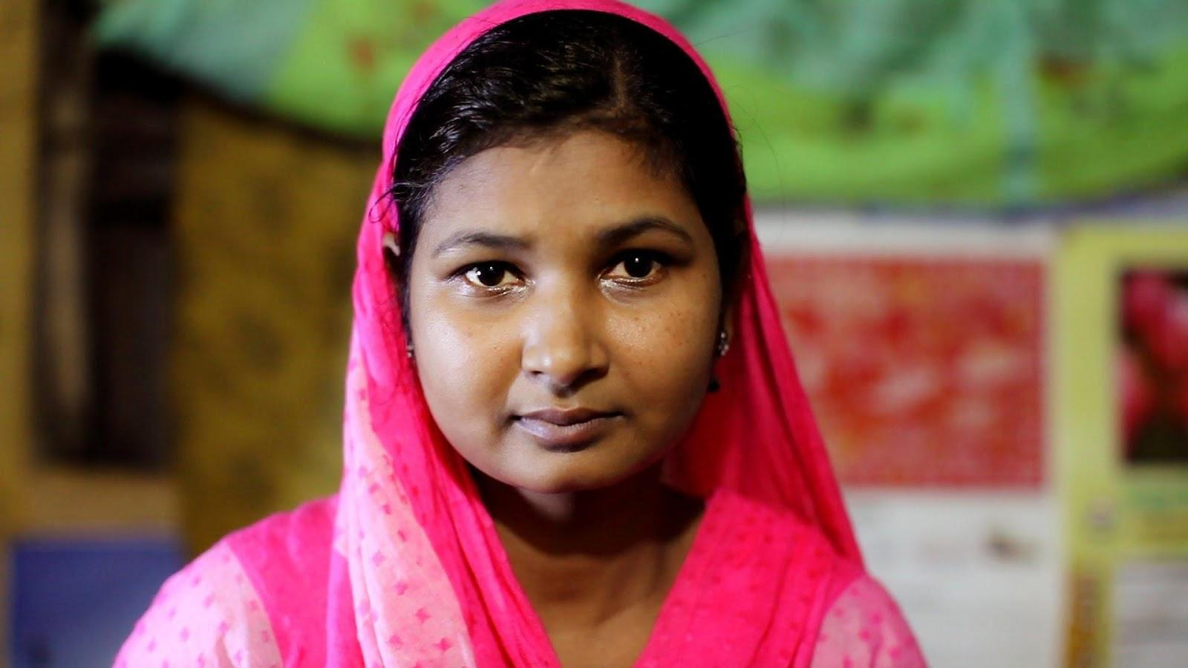

1. What is outsourcing? (Answer these questions using what you know already or from the textbook.)

2. What is globalization?

A. Watch/Read: http://ww2.kqed.org/lowdown/2015/03/18/making-your-t-shirt-a-journey-around-the-world/

1. What surprises you about the map?

Why?

2. Why do the clothes travel tens of thousands of miles?

 B. Watch/Read:

http://www.cbc.ca/fifth/episodes/2013-2014/made-in-bangladesh

1. What is life like for the people who make clothes in Bangladesh?

2. Why are there so many Bangladeshi factories making American clothes?

3. How do clothes companies benefit from low wages?

4. How do consumers (YOU) benefit from low wages?

5. What are some ways globalization actually helps Bangladesh?

6. What is ‘clothes without a conscience?”

7. What is the race to the bottom? What is fast fashion?

8. Where is Rana Plaza? What happened there?

9. Who was to blame for the tragedy?

10. How can this tragedy be prevented in the future?

11. What other injustices take place in the garment industry in Southeast Asia?

12. As consumers, where do we go from here?

 C. Watch/Read:
http://ww2.kqed.org/lowdown/2013/05/24/madeinamerica/

1. From 1960 to the present, what’s the general trend for percent of money spent on clothes?

2. From 1960 to the present, what’s the general trend for percent of clothes made in the U.S.?

3. What are three reasons why clothes (and most other things) are less likely to be made in the U.S.?

4. Write a paragraph answering this prompt: are you willing to pay extra to make sure the workers who make your clothes are paid a decent wage? Why or why not?

Re-read pgs. 11-17 in your textbook or the Online Textbook
Then, watch the video called Canada’s Lubicon Lake Nation Continue Anti-fracking Campaign, Appeal Court Injunction
Once you’re done watching the video, answer the questions below:

1. Create a timeline showing the events that have affected the identity of the Lubicon Cree. For each event, write a phrase or sentence that identifies its connection to the Lubicon Cree. (Your timeline can be an actual line ------------- or it can be a list.)

2. Think about your understandings of globalization so far. Name at least two aspects of globalization that have affected the Lubicon. Would you rate these effects as positive or negative? Explain why.

3. . Name at least two ways the identity of the Lubicon Cree has been challenged. Think about the aspects of your own identity you described earlier in this chapter. How would you respond if someone told you that you are wrong about one or more aspects of your identity — that you are not who you say you are?

4. After watching the video on “Canada’s Lubicon Lake Nation Continue Anti-fracking Campaign, Appeal Court Injunction,” describe all of the reasons why the Lubicon Cree are protesting and why they have had to go to court?

5. Read the following article and summarize what happened in the Fall of 2018.
https://nationalpost.com/news/politics/albertas-lubicon-lake-first-nation-to-ink-land-deal-today-with-feds-province

What is Identity?
As you begin to explore the concept of globalization, you will have many opportunities to think about the many ways that globalization affects your life and your identity. Let's start by taking this short and hilarious quiz to get you thinking about your own identity.
What Country Do You Actually Belong In?
Of course, this is just a playful way to start our conversation about globalization and identity. What did you get?

Watch the following film by clicking on the blue link: No Logo Film
Once you’ve finished watching the film, answer the question below:
Persuasive Letter Assignment
The Scenario: Your school is thinking about implementing a one laptop per student or “one to one” program at your school. To fund the program, the school will allow advertising on school computers and handheld computing devices. (Think Facebook giving millions to a New Jersey school with strings attached.) The school has asked for student feedback and you have been chosen to represent the student perspective.
Your audience- Fellow students, school administration, and the school board.
Your Task: You are asked to present a speech OR write a letter of support for the program or a letter of opposition.
The Issue- “One to one” computing in your school and advertising being directed at students to fund the program.
Using your understanding of media literacy and the effect of media in schools on adolescents, persuade the school to adopt the program with advertising or convince them NOT to implement the program and seek another avenue for funding.
Write your persuasive letter in this text box!

Part 2/Chapter 2: Identity and the Forces of Globalization

Read chapter 2 and watch: Appropriation vs Appreciation
What are your thoughts on the short video you watched?
In this part of the course you will be asked to ponder, research and analyze information so you can answer the following questions:
- What are some forces of globalization?
- How is identity affected by some political, economic, social, and environmental dimensions of globalization?
- How do some forces of globalization present challenges to identity?
- How do some forces of globalization provide opportunities to affirm and promote identity?
KEY TERMS to DEFINE!
- transnational corporation
- media concentration
- media convergence
- biodiversity
- stereotyping
- overgeneralizing
- homogenization
- acculturation
- accommodation
- assimilation
- cultural revitalization

Bananas: The Facts
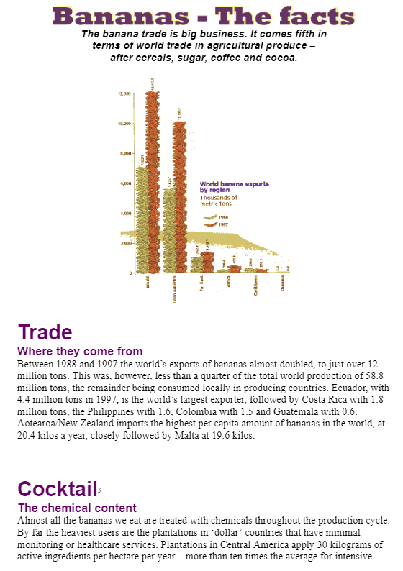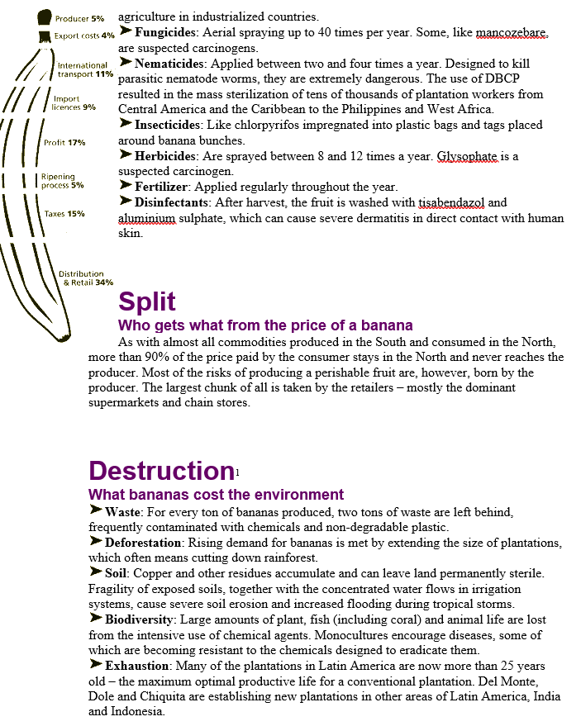
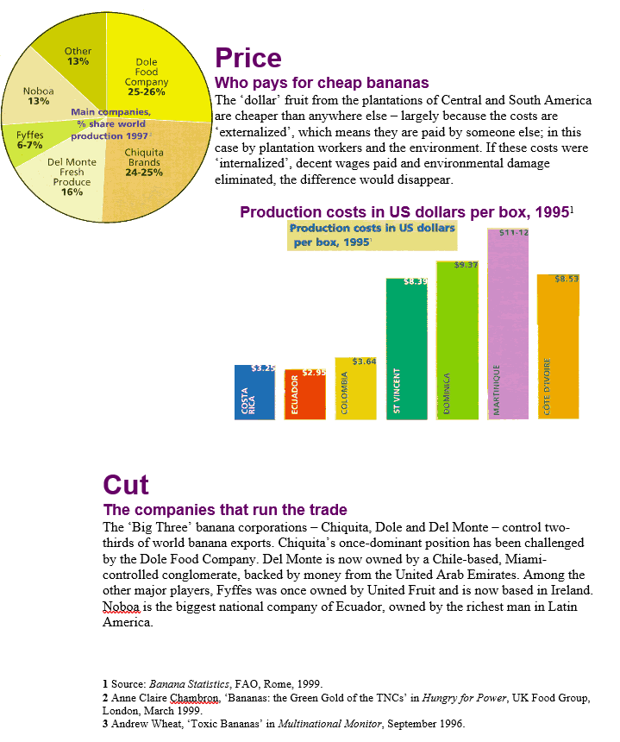
Read the article Banana Road
Then complete the assignment below:
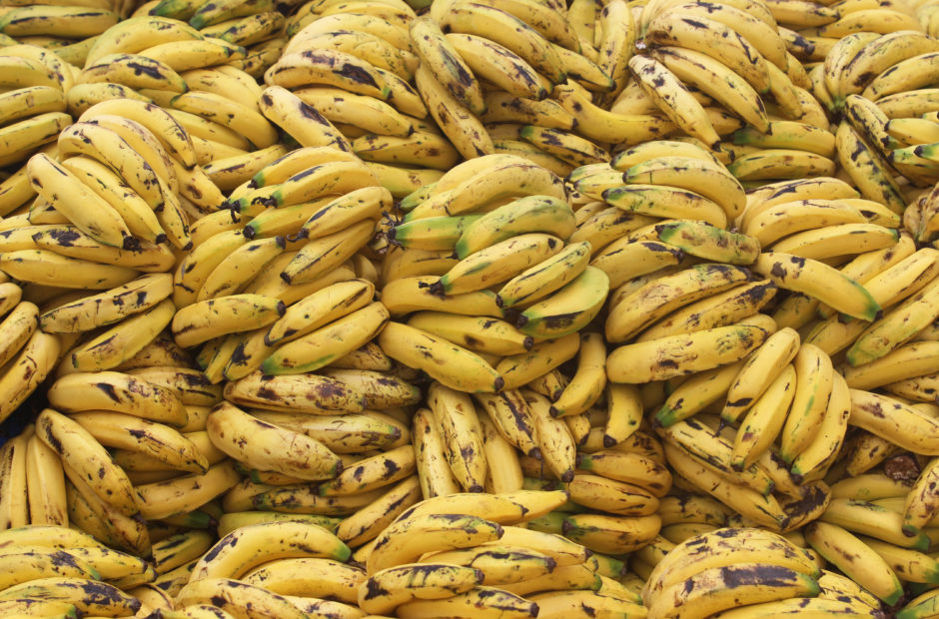

Banana Road
Maria Jose Burgos
December 2, 2018
Questions (to accompany article)
https://newsinteractives.cbc.ca/longform/banana-republic
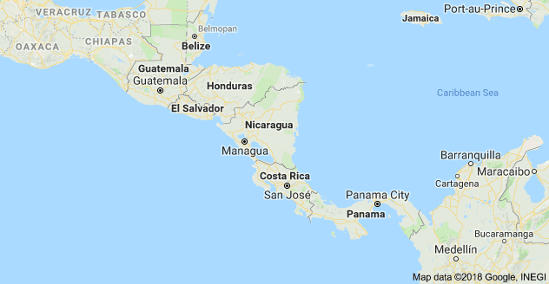
- Why are Hondurans joining caravans that are “trudging toward the U.S.?”

The Banana Man

- Where was Samuel Zemurray from? How did Zemurray make his fortune?

A Walk for a Wage

- What is United Fruit called today? Why did young people walk days from south to north?
- Why did Honduras allow companies to do as they pleased?
- How were the Honduran workers treated?
- What happened in 1954?

A Lost Way of Life

- What were the consequences of the reforms that were won?
- How does Noe Pino describe the legacy that the banana industry has left behind?

A Punishing Storm

- What natural disaster happened in 1998 and what were the results on Honduran society?

Stories of Flight

- What is an economic refugee?
- What is a “coyote?”
- What do Hondurans do once they make it to the U.S.?

No role models

13. Why are role models hard to find?

14. What happened with Honduran political leadership nine years ago?

15. Why is protesting in Honduras risky?

16. What needs to happen in Honduras so young people want to stay?

Part 3/Chapter 3: Identity, the Media, and Communication Technology
Read Chapter 3
To what extent is identity affected by communication technology and the media in a globalizing world?
In this part of the course you will be asked to ponder, research and analyze information so you can answer the following questions:
• How is identity affected by opportunities to communicate with people around the world?
• How is diversity influenced by the media and communication technologies?
• How is identity affected by media coverage of world events?
• How is diversity affected by the dominance of American media?
Key Terms to define below:
- digital divide:
- propaganda

- pop culture
- universalization
- hybridization

After reading Chapter 3, choose EITHER Question # 3 on page 86 OR Question #4 on page 87 and complete your answer in the space below.

Chapter 3 PDF link

Reread pages 51 - 69 (Chapter 3) in the Online Textbook
Then, complete the assignment below.

Identity, the Media, and Communication Technology Assignment

For this assignment, answer ONE of the following questions:

- According to Marshall McLuhan, all media affect people’s identity in some way. Think about five messages you have recently received via the media: TV, radio, a magazine, a billboard, a movie, or another source. Consider how each message might be trying to influence or change you — to manage your worldview in some way — and how these influences might be affecting who you are: your identity. Create a chart like the one shown and use it to assess each of the five messages you selected. A sample response has been filled in for you.

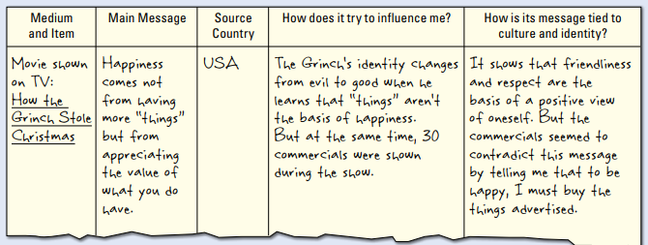

- Zara Houshmand is an Iranian-born American writer who wrote the poem on this page soon after the September 11, 2001, attacks on the United States. At the time, the news was full of accusations against various Muslim groups — and “Another Day and Counting” expressed Houshmand’s feelings about the media messages that were affecting her identity.

Another Day and Counting
by Zara Houshmand

It’s routine now:
I drive my son to school,
the sun just breaking through Pacific mist.
Driving home, I listen to the news
and quietly cry.

My son won’t listen anymore:
“All opinions, hot air. Call me when they
find some facts.”
Proud and fragile privilege of youth:
demand the truth.

The sky recedes, ashamed.
What passes now for truth on this cold ball?
The sky is pink with shame
beyond the concrete ribbons where commuters crawl.
What’s in that microscopic dust
that bends our light to post-card pinks?
Dust of concrete hopes exploded,
dust of homes of sun-baked brick,
complex chains of human dust
and dust of promises to youth.

Tonight my cheeseburger arrives
with a flag poked proudly in the bun.
The tiny paper stars and stripes seem far away,
victory through the wrong end of the telescope,
moon-landing on the circle of my plate.
The waitress smiles broadly,
but the food tastes bad,
or maybe I’ve just lost my appetite.

- Select five words and phrases Houshmand uses to express her emotional state. Describe her emotional state in your own words.

- After the twin towers of the World Trade Center collapsed, dust filled the air for days. In the second stanza, Houshmand uses the word “dust” five times. Explain the meaning contained in this word each time she uses it.

- In the final stanza, Houshmand wrote: “The tiny paper stars and stripes seem far away.” Explain what this sentence means. How does it reflect her mixed emotions about her identity as an Iranian and as an American?

- Reread the final sentence of the poem. It starts, “The waitress smiles . . .” Explain how this sentence sums up Houshmand’s mixed feelings about what has happened — and what is happening.

Part 4/Chapter 4: Affirming Identity, Language, and Culture

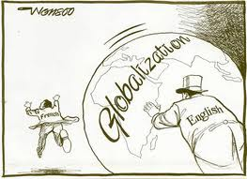
Read Chapter 4! Watch: TOP 10 PROBLEMS
List 2 from the film:
In this part of the course you will be asked to ponder, research and analyze information so you can answer the following questions:
• How do people affirm and promote their language in a globalizing world?
• How do people affirm and promote their culture in a globalizing world?
• How do governments affirm and promote languages and cultures in a globalizing world?
• How do international organizations affirm and promote languages and cultures in a globalizing world
Key terms. Define them below!
- cultural content legislation:
- cultural diversity:
- language laws:
- linguistic revitalization:
- linguistic rights:

Reread pages 73 - 84 in the online text.
Watch the following video called:
Ancient Futures: Learning from Ladakh
Once you’re done watching the video, answer the questions below:

Ancient Futures: Learning from Ladakh

Watch Ancient Futures: Learning from Ladakh (from 3:07 - 24:00). As you watch the film, look for as many aspects of culture as you can in three columns:

Ideas/Attitudes/Beliefs (Think) | Behaviours/Relationships (Do) | “Artifacts”/ Elements of Culture: animals/tools/clothes/homes, etc. (Have)

What key cultural elements have sustained Ladakh for over 1000 years?

Are there particular pieces of culture that, if taken away, Ladakh would stop being Ladakh and the culture might begin to erode?

YOU HAVE REACHED THE END OF THE MODULE! You may begin looking over the review portion of the Unit on Brightspace. Check your course outline for the due dates for each Unit quiz exam and essay response. CONTACT YOUR TEACHER FOR YOUR UNIT ASSESSMENTS.
Key terms to study:
Economic globalization
Collective identity
Hybridization
Acculturation
Cultural homogenization
Accommodation
Sustainability
Transnational
Cultural revitalization
Acculturation
Outsourcing
Marginalization
Global culture
indigenous

